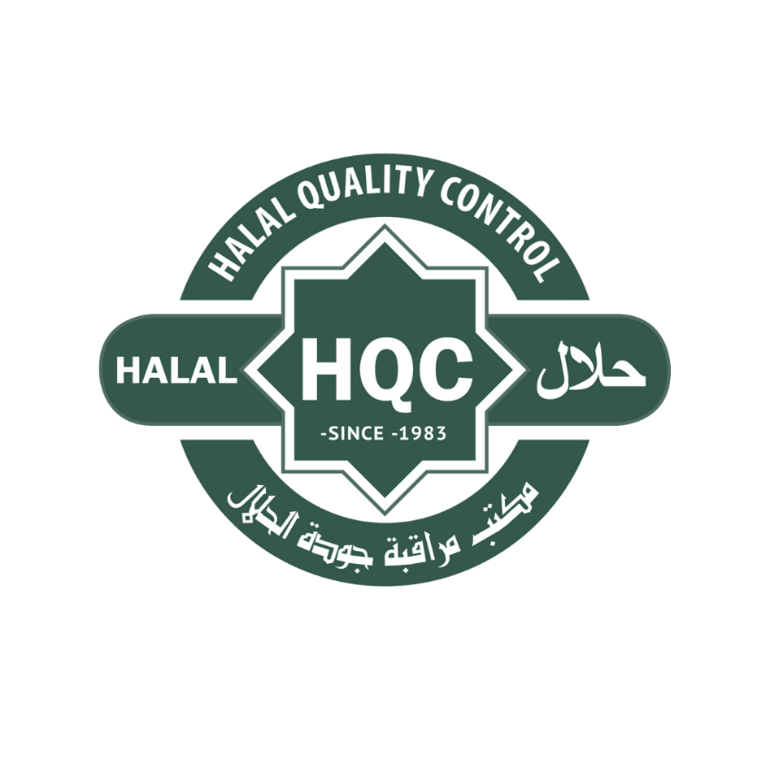

Version:
10.1

Authored and Managed by:
Halal Quality Control Headquarters, The Netherlands

Target Audience:
Applicants, certified clients, existing customers, service providers, private label owners, slaughtering facilities, manufacturers, laboratories, traders, and other organizations seeking Halal certification or scope extension through HQC.

How to Use this Form
This form collects the minimum information required for HQC to review an application, determine the applicable certification scope, identify relevant Halal risks, select the correct Scheme and reference standard, and prepare a quotation, contract, or audit plan where applicable.

Copyright
© Control Office of Halal Slaughtering and Halal Quality Control BV [COHS and HQC] and Chamanco BV 2026
© Registered trademark symbols: Halal Quality Control Mark and the HCS by HQC Logo
All rights reserved. No part of this publication may be transmitted or reproduced in any form (including photocopying or storage in any medium by electronic means) without the written permission of the copyright owner. Application for permission should be addressed to the Writer of the Management Department (contact details below). Full acknowledgment of the author and sources must be given.
The contents of this publication cannot be reproduced for training or any other commercial activity.
No part of this publication may be translated or reproduced without the permission of HQC, except where HQC provides authorized translations.
Warning: Any unauthorized act in relation to a copyrighted work may result in both a civil claim for damages and criminal prosecution.
Published by: COHS and HQC BV (HQC Headquarters)
Laan van Meerdervoort 53d, 2517AE, The Hague, The Netherlands
Tel: +31 (0) 70 346 97 95 | Email: info@halalqualitycontrol.com | Website: www.halalqualitycontrol.com
Edited and typeset by: Wasim al Shaman

1. Applicant and Company Information
Question / Required information | Applicant response
Application type | ☐ New application ☐ Existing customer update  ☐ Renewal / recertification ☐ Scope extension ☐ Additional site ☐ Other:
Date of application
Official legal company name
Trade name / brand name(s), if different
Business registration number
VAT / tax number
Legal address
Invoice address, if different
Country of registration
Website
General contact person | Name:  Function:  Telephone / WhatsApp:  E-mail:
Financial contact person | Name:  Function:  Telephone / WhatsApp:  E-mail:
Quality / Halal contact person | Name:  Function:  Telephone / WhatsApp:  E-mail:
Preferred language for communication | ☐ English ☐ Dutch ☐ French ☐ German ☐ Italian ☐ Spanish ☐ Arabic  ☐ Other:

2. Certification Request and Scope
2.1 Applicable sector(s)
☐ Slaughtering / animal slaughtering | ☐ Meat or animal product processing
☐ Dairy | ☐ Ingredients / additives / processing aids
☐ Confectionery / bakery | ☐ Beverages
☐ Condiments / sauces / spices | ☐ Synthetic or industrial chemicals
☐ Cosmetics and personal care | ☐ Drugs / pharmaceuticals / supplements
☐ Animal feed | ☐ Packaging, repacking, or labelling
☐ Storage / logistics / tank storage / transport | ☐ Trading or private label ownership
☐ Laboratory testing | ☐ Central kitchen / catering
☐ Service provider (non-manufacturing) | ☐ Other:

Question / Required information | Applicant response
Requested certification scope | Describe the products, services, processes, brands, sites, or activities requested for Halal certification.
Brief product or service description
Number of products / SKUs requested
Estimated Halal production or service volume per year (where applicable) | Indicate kilograms, tons, liters, units, batches, shipments, or another suitable unit.
Brands covered by this application
Are products sold under private label? | ☐ Yes ☐ No  If yes, identify brand owner(s), legal ownership, and manufacturing location(s).
Are third-party products included? | ☐ Yes ☐ No  If yes, identify supplier(s), product owner(s), and available certificates.
Preferred reference Halal standard, if known | ☐ OIC/SMIIC ☐ SJPH/BPJPH ☐ MS/JAKIM  ☐ GSO/UAE.S ☐ Other  ☐ Unknown / HQC to determine

2.2 Intended Market Destinations
☐ United Arab Emirates | ☐ Saudi Arabia
☐ Qatar | ☐ Other Gulf Countries:
☐ Indonesia | ☐ Malaysia
☐ Singapore | ☐ Türkiye
☐ Pakistan | ☐ Thailand
☐ European Union / United Kingdom | ☐ United States / Canada
☐ Domestic Market | ☐ Other:

Selected destination markets may require additional documentation, specific certificate formats, shipment certificates, laboratory testing, authority fees, registration, or restrictions. HQC will determine applicable requirements during application review.

3. Site, Process, and Operational Information
Question / Required information | Applicant response
Main site covered by this application | Site name:  Address:  Country:  Activity at this site:
Additional sites covered by this application | ☐ No additional sites  ☐ Yes, list all sites and activities below:
Manufacturing or processing performed by applicant | ☐ Yes ☐ No ☐ Partly  If partly or no, identify outsourced process owner(s).
Outsourced activities | ☐ None ☐ Manufacturing  ☐ Packaging / repacking ☐ Labelling ☐ Storage ☐ Transport ☐ Tank storage ☐ Other:
Number of employees involved in the relevant scope
Production or service frequency | ☐ Daily ☐Weekly ☐ Monthly ☐ Seasonal ☐ On demand ☐ Other:
Food safety, GMP, or quality system certification | ☐ BRCGS ☐ IFS ☐ FSSC 22000 ☐ ISO 22000 ☐HACCP ☐ GMP ☐ ISO 22716 ☐ISO 9001 ☐ ISO/IEC 17025 ☐ None  ☐ Other:
Regulatory approval or license, if applicable | Examples: EC number, veterinary approval, cosmetic notification, pharmaceutical license, laboratory scope, slaughterhouse approval, food business registration.
EC / EG / veterinary approval number, if applicable

4. Halal Risk and Compliance Questions
The following questions help HQC determine the initial risk classification and the required supporting documents. The applicant may answer and provide remarks where relevant to speed up the procedure.

Question / Required information | Applicant response
Has the company previously held Halal certification? | ☐ Yes ☐ No  If yes, certification body name, expiry date, and reason for transfer or change:
Is the company currently Halal certified? | ☐ Yes ☐ No  If yes, attach certificate and product list.
Has any certification ever been suspended, withdrawn, refused, or restricted? | ☐ Yes ☐ No  If yes, explain:
Are pork, pork derivatives, pig-derived ingredients, or porcine materials present at any site included in this application? | ☐ Yes ☐ No  If yes, explain location, segregation, and controls:
Are non-Halal meats, animal derivatives, blood, plasma, placenta, or animal by-products present at any site included in this application? | ☐ Yes ☐ No  If yes, explain:
Are animal-derived materials used in products, processing aids, packaging, cleaning agents, equipment, or indirect contact materials? | ☐ Yes ☐ No  Examples include gelatin, collagen, rennet, tallow, glycerine, fatty acids, enzymes, keratin, lanolin, carmine, shellac, amino acids, and animal-based proteins.
Are insect-derived materials used? | ☐ Yes ☐ No  Examples include carmine, shellac, insect protein, insect oil, or insect-derived additives.
Is ethanol, alcohol, fermentation-derived material, alcohol-based extract, flavor carrier, fragrance carrier, or alcoholic solvent present? | ☐ Yes ☐ No  If yes, identify material, function, source, and estimated final concentration.
Are Halal and non-Halal products produced, handled, stored, transported, or packed in the same facility or on shared equipment? | ☐ Yes ☐ No  If yes, please describe here or during the documentation stage.
5. Applicant Declaration
By signing this form, the applicant confirms that the information provided is accurate to the best of its knowledge and that the applicant will inform HQC of any significant changes that may affect the application or the scope of certification.
The applicant understands that this form does not grant Halal certification, does not authorize the use of the HQC Halal mark, and does not replace a quotation, certification agreement, audit plan, or certificate.
The applicant agrees that HQC may review the submitted information, request additional documentation, determine the applicable Scheme and standard, assess risks, and decide whether the application can proceed.
Question / Required information | Applicant response
Authorized representative name
Function / title
Company name
Date

6. HQC Application Review (Internal Use Only)
This section shall be completed by HQC personnel during the application and contract review process. It supports accreditation requirements by documenting the review outcome, applicable scope, required competence, risk classification, and decision on whether the application can proceed.
Question / Required information | Reviewer response
Date received
Received by
Application complete? | ☐ Yes ☐ No ☐ Partly  Missing information:
Applicant status | ☐ New customer ☐ Existing customer ☐ Other:
Applicable HQC Scheme(s) | ☐ HAP Scheme  ☐ AWS Scheme  ☐ Supervision Scheme  ☐ HSP Scheme  ☐ Cosmetics and Personal Care Scheme
Initial risk classification | ☐ Low / Medium ☐ High Risk ☐ Critical  ☐ To be determined
Applicable reference standard(s) | ☐ OIC/SMIIC ☐ UAE.S ☐ GSO  ☐ BPJPH / SNI / SJPH ☐ Malaysian Standard ☐ Other:
Potential impartiality or conflict concerns | ☐ Yes ☐ No  Remarks:
Quotation and contract required? | ☐ Yes ☐ No  Remarks:
Category / Scope  Overview of Categories and Scopes available.  Please click here. | Remarks:
Application review outcome | ☐ Accepted  ☐ Requires clarification ☐ Rejected  ☐ On hold
Reason for rejection or clarification, if applicable
Reviewer name and function
Review date
Second reviewer, if applicable
Management approval, if required
Comments, if any

Appendix A: Initial Risk Classification Guidance
The table below is only an initial guidance tool. Final classification may depend on product composition, source, process, destination market, authority requirements, and HQC review.
Classification | Examples and interpretation
Critical | Animal derivatives, meat, gelatin, collagen, tallow, rennet, fats, enzymes, glycerine, animal powders, keratin, vitamins from animal sources, insect derivatives, blood, plasma, bio-cultures, certain alcohol-based products for consumption, products containing critical components, and any product or material requiring stricter Halal verification.
High Risk | Dairy products, cheeses, flavored yoghurts, dairy desserts, supplements, confectionery, bakery premixes, sauces, condiments, edible oils, beverages, processed fish products, ready meals, vinegar, vegetarian or vegan products with complex ingredients, dried spices, cosmetics, pharmaceuticals, processing aids, and food additives.
Low to Medium Risk | Materials and products with limited Halal risk, such as many fresh fruits and vegetables, fresh fish and egg-based products, bee-derived products, fresh spices, natural oils, plant and flower-based items, mineral water, mineral-based products, grains, pulses, and simple chemical or mineral materials, subject to HQC review.

Appendix B: Applicable HQC Guidelines and Forms

In general, most guidelines and forms are publicly available at www.halalqualitycontrol.com/en/support-documents or may be requested by e-mail if they are classified as non-public documents.

Appendix C: Examples of (Critical) Control Points

Halal Control Point Guidelines available:
- Halal Control Points for the Food and Beverage Sector (0492-1)
- Halal Control Points for the Chemical Sector (0492-2)
- Halal Control Points for the Drugs and Pharmaceutical Sector (0492-3)
- Halal Control Points for the Cosmetics Sector (0492-4)

The Control Point Guidelines can be downloaded through our Supporting Documents page.

Appendix D: HQC Schemes

Some Schemes are publicly available on www.halalqualitycontrol.com, while others are available only upon request. Executive summaries are publicly available at www.halalqualitycontrol.com/en/hqc-schemes-en

All Schemes have corresponding checklists that are used during the assessment.
These aspects are covered under other HQC Schemes, including:

Scheme name | Description
Halal Certification Scheme | Defines the overall framework, requirements, and procedures for obtaining and maintaining Halal certification, including application, assessment, decision-making, and certification governance.
Halal Assurance Program (HAP) Scheme | Defines requirements for animal handling, slaughtering, and post-slaughter operations to ensure compliance with Islamic principles, animal welfare, and applicable regulatory standards.
Animal Welfare and Slaughtering (AWS) Scheme | Defines Halal requirements for organizations providing services related to Halal products, including logistics, storage, cleaning, pest control, and other outsourced activities that may impact Halal integrity.
Halal Service Provider (HSP) Scheme | Defines Halal requirements for organizations providing services related to Halal products, including logistics, storage, cleaning, pest control, and other outsourced activities that may impact Halal integrity.
Cosmetics and Personal Care Scheme | Defines Halal requirements for cosmetic and personal care products, including ingredient origin, formulation, processing, packaging, labelling, storage, contamination control, alcohol use, applicators, and product-specific considerations such as water permeability and oral-contact risks.
Supervision Scheme | Defines the rules for on-site Halal supervision by HQC personnel, including the roles and responsibilities of Halal supervisors, monitoring activities, and reporting obligations.
Laboratory Testing Scheme | Defines requirements for laboratories performing Halal-related testing, including sampling, analytical methods, result interpretation, and reporting to HQC where applicable.

Appendix E: Document Control and Updates

HQC maintains control over all Schemes, Guidelines, Forms, and Procedures.
Documents may be revised, replaced, or withdrawn to reflect regulatory updates, optimize layout and details, accreditation requirements, or operational improvements.

Appendix F: Language and Translation

The official version of this form is the English language version. HQC may provide (un)official translations of this form and related documents for convenience and accessibility.
However, in case of any difference in meaning, interpretation, or application, the English version shall prevail. These translations are provided as a supporting tool and do not replace the official English version.

Need Help or Assistance?
Your HQC contact or office partner can guide you through this form or answer any questions you have.
You may contact us by emailing info@halalqualitycontrol.com or by calling/messaging us at +31 70 346 97 95 (WhatsApp available for multilingual communication).

